In 2022, Holy Trinity Church Nice – Europe’s oldest Anglican chaplaincy - celebrated its bicentenary.
In 1820, a group of British winter residents applied to the King of Sardinia (who then ruled Nice from Turin) for permission to establish a protestant place of worship in Nice. This was granted and the foundation stone was laid in September 1821. The building was completed by the following November, on condition that it looked like an ordinary house, and the first service took place on Advent Sunday 1822, performed by Rev. Lewis Way, the driving force behind the construction of the now world-famous Promenade des Anglais .
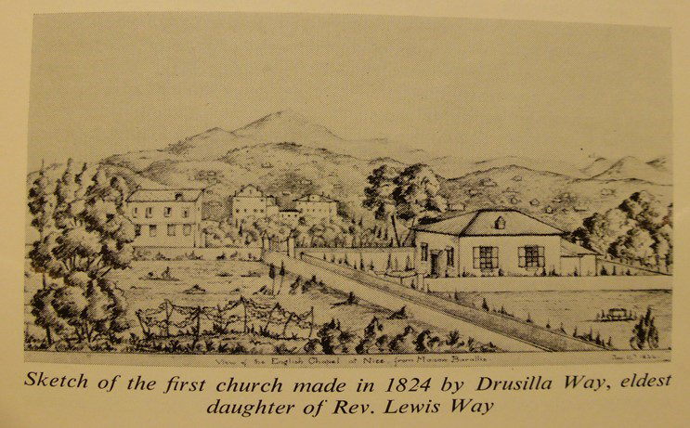
Very quickly, this first church became too small and was demolished. The first Bishop of Gibraltar performed a Consecration Ceremony for the current church on 22 December 1862. Holy Trinity Nice was officially classified as a monument historique in November 2020, and as such is part of the City of Nice’s rich cultural heritage for which it was awarded Unesco World Heritage status in July 2021.

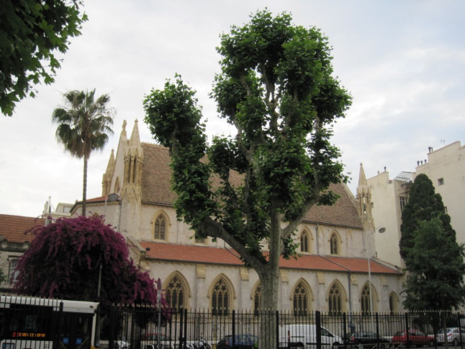

Since 2022 marked the bicentenary of the founding of Holy Trinity Nice and 200 years of Anglican worship in Nice, the church celebrated this landmark with a series of events which started with the Feast of the Holy Trinity which fell on the second weekend in June.
The weekend began with 2 chamber concerts given by Margi MacDuffie and Joe Voelker in the presbytery, all proceeds from which were donated to Ukraine.
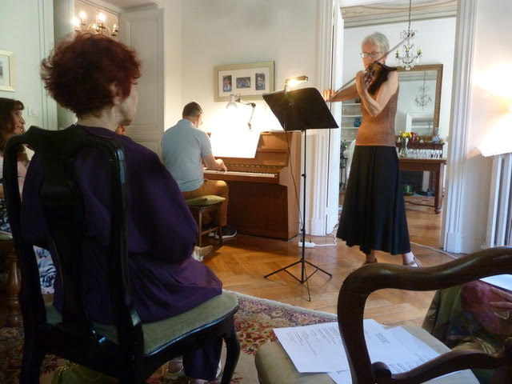
On Saturday 11 June there was a Scottish-style ‘Tea & Dance’ in the church gardens. Tea was followed by an apéro with light entertainment (including a Bicentenary March specially written by Holy Trinity’s secretary Bob Tonkiss)
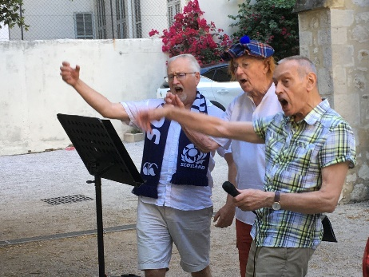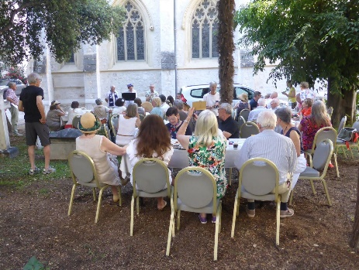
and ceilidh dances which were greatly enjoyed by all the generations present.
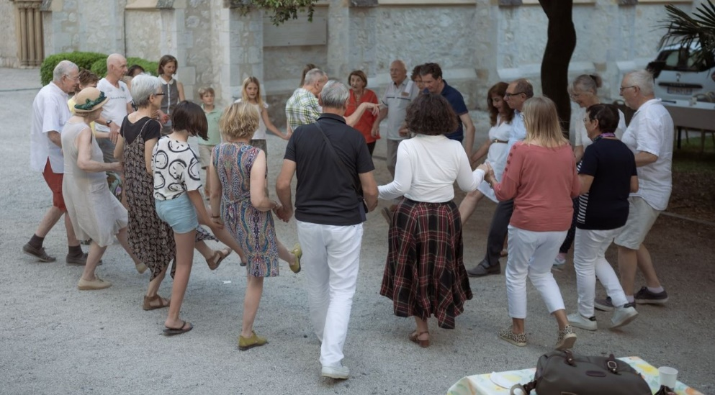

On Sunday 12 June, the festal service for the Feast of the Holy Trinity was celebrated by Rev. Peter Jackson and attended by Christian Estrosi, the Mayor of Nice, and other dignitaries.
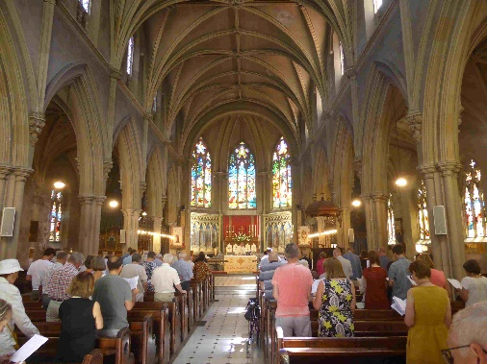
Afterwards, guests and parishioners enjoyed a sumptuous buffet prepared by parishioner Joёlle Paterson and served outdoors in the church grounds.
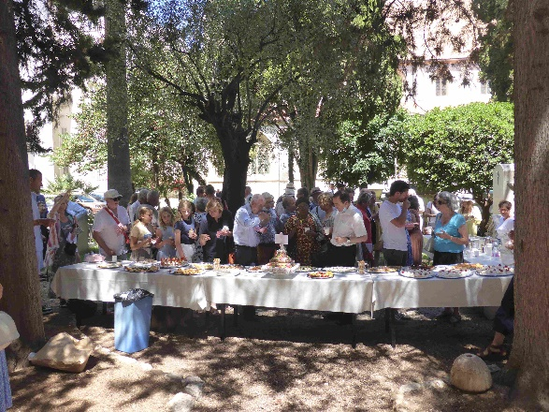

Tragically, all sense of celebration was abruptly extinguished when Rev. Peter Jackson passed away very suddenly at the end of August.
However, the church was open for the Journées européennes du patrimoine on 17/18 September and 160 visitors were welcomed.
On 23 November, our resident historian and Church Warden, Richard Challoner, gave a fascinating illustrated talk on the early years of Holy Trinity in the recently refurbished parish hall. His presentation was very much appreciated by everyone present.
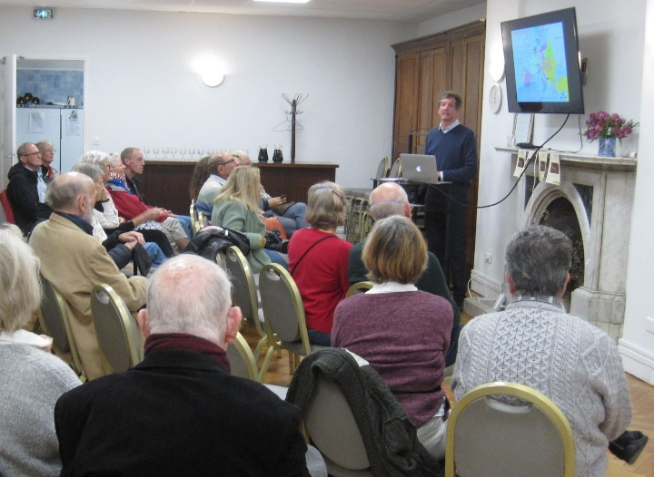.
Saturday 26 November: a sense of bicentennial celebration returned with an exhilarating concert given by Brass Band Méditerranée which was received with rapturous applause. The concert’s second half comprised music specially arranged for the evening and conducted by Roy Terry, a longstanding member of the congregation.
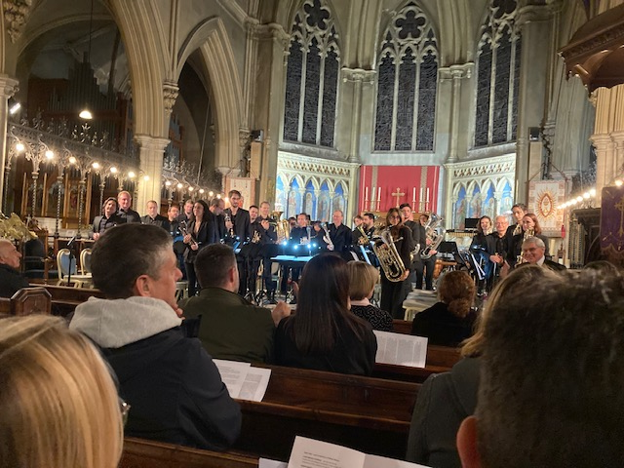
The 200th anniversary of the first service in 1822 was celebrated on 27 November, Advent Sunday and jointly officiated by Rev. Terry Winrow and Archdeacon Peter Hooper. Members of our sister church St Hugh’s in Vence came to celebrate the bicentenary too.
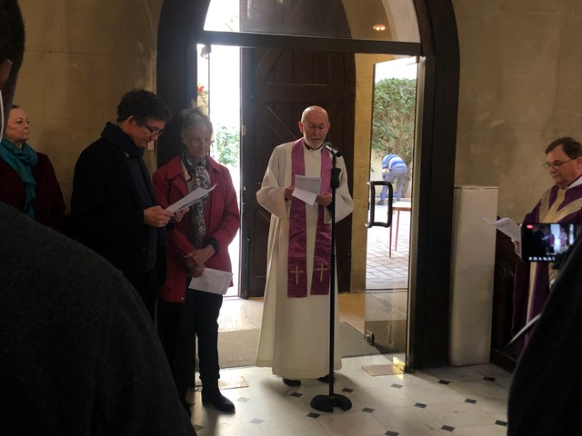

This special service was followed by a special buffet, provided by parishioners.
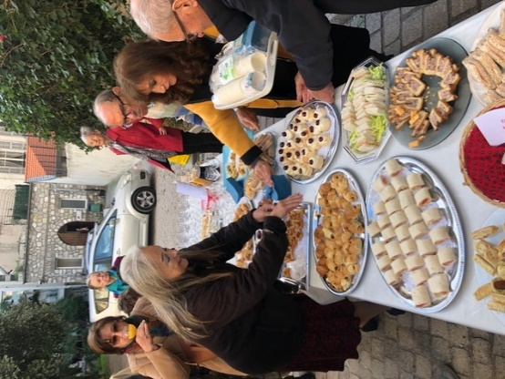

2022 was indeed a memorable year for Holy Trinity Nice – the joy of worshipping after the easing of Covid restrictions and of celebrating a bicentenary was tempered by the huge and tragic loss of Rev. Peter Jackson. Nevertheless, the Wardens, Church Council and congregation rallied together to ensure that Holy Trinity Nice’s bicentenary was suitably commemorated.

