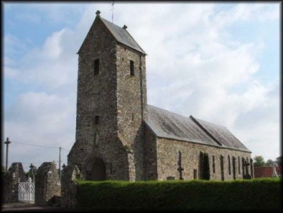
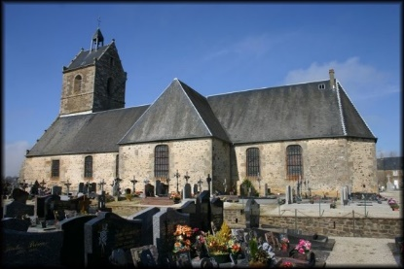
Synod Report
2021
Gratot Church
Virey Church

Now in our 7th year of interregnum life here in the Manche has changed dramatically due to the Covid Pandemic as it has throughout the world. Our Reader-in-Training Donna Derrick was finally licensed at the beginning of January 2020 after several months of waiting. A joyous occasion for the whole chaplaincy and our ecumenical partners as we came together to witness Rev. Canon Debbie Flach, our Area Dean come and preside over the event to formally admit Donna, mere weeks before France went into total lockdown.
Since then it has been a time of adapting our worship patterns to the constantly changing situation, learning and using new and often unfamiliar technology to provide services for our widely dispersed congregations whilst maintaining pastoral care of our aging flock. Over the months we have become adept Youtuber’s and podcasters. During the summer with the permission of the Maire and Catholic Church we were able to install an ethernet cable from the presbytery to the Church in Gratot to provide internet access. This greatly enhanced our summer services when we were able to record and upload the live services for those unable to come to Church especially those in the South of the department as Virey Church remained closed.
Whilst unable to socialise it became apparent that the congregations greatly missed the physical contact of meeting and worshipping together in Church. So when the further lockdowns came into force we started to worry about the mental wellbeing of our flock.
Also the health of our retired PTO ministers was becoming a worry, as they suffered a number of health issues resulting in hospitalisation for one and the stepping back for a while from ministry for another. It was at this time that Canon Debbie stepped in to formalise a working agreement for Donna under her direction. This was put in place with the agreement of the Church Warden and retired Ministers, and she was duly appointed Leader and Convenor of the Chaplaincy under the authority of Canon Debbie and with the full support of the Chaplaincy at the end of 2020.
This has obviously resulted in a number of changes and given the distance between personnel, zoom was suggested as an obvious format. Despite reservations it was decided to try it out, and apart from a few internet speed glitches (this is after all back of beyond rural Normandy;) it has proved rather successful. Donna and the PTO ministers along with the Church Warden now meet weekly as a leadership team to discuss events as they unfold in order to keep everyone up to date. She also meets monthly with Canon Debbie to bring her up to date on developments. Friday Focus has been reinstated, a weekly newsletter to the Chaplaincy with details and links to forthcoming services along with a precis of the Leadership team meeting. Also, when something changes i.e. the new French attestation documents, three different ones in as many days…. These too are sent out to the congregation. Those without internet or printing facilities receive hard copies via snail mail to ensure everybody is kept up to date and included.
To help with the obvious mental health issues of isolation, it was decided to try a zoom afternoon tea. This proved highly successful, with the consensus of opinion that they should be repeated but perhaps in the morning. So was born the ‘Coffee Catch-up morning’ on zoom. Every other Wednesday at 11am local time, 10am UK time with the link on our ACNY website, some of us come together for an informal time of talk about anything and everything. It has also allowed our second homeowners who cannot come across at the moment to reconnect with the Church family here providing a much-needed lifeline.
Zoom also proved invaluable recently for the funeral of one of our Chaplaincy’s founding Fathers whose family could not get across for his final farewell. We were able to livestream on zoom using our techno-bod Morgan, up in Lille with Canon Debbie, to facilitate for us and ensure that everyone who wanted could connect to the service. It was also recorded so that those who were unable to join could get the details again from the website to make their own farewells to John. As a first time it was a relief when it all came together so well.
As our understanding and familiarisation of the technology available becomes better, so we are improving our services to our people better. We are becoming a more mixed mode Church being able to provide live services as well as recordings for those still too vulnerable to risk being in a relatively closed environment.
We now provide twice monthly live services for those who feel able to come to Gratot whilst at the same time recoding the service for those who are unable to attend. Virey is looking to hold a monthly service in their huge edifice of a Church whilst waiting for the better weather when they can meet more frequently out of doors.
We have obviously lost members, especially as a result of Brexit but we are re-connecting with others. No-one knows what the future holds or where we will be in a year or two years’ time. We never thought we’d still be in lockdown this year, or that we’d still be in an interregnum, but with God’s help and guidance we will get through this and come out the other side. Probably different and maybe smaller, but almost certainly stronger.

Donna DERRICK
Licensed Lay Minister

