Chaplaincy Report : All Saints, Vendée, for the year 2020.

All Saints, Vendée, covers the whole of that department, and also has members living in the Deux Sevres, touching the south of the Loire region, one member often travels from Nantes to join us for worship once a month.

We began the year normally enough, worshipping in two centres, on the first, second, and fourth Sundays of the month, each service followed by a bring and share lunch.

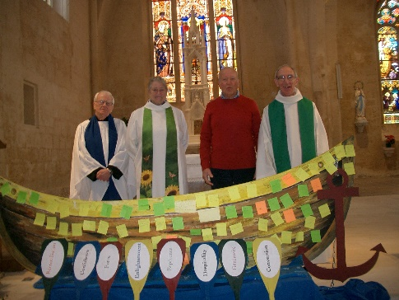
We once again joined our catholic and protestant brothers and sisters in the service to celebrate the Week of Prayer for Christian Unity. Our Chaplain preached the sermon in both French and English, much to her surprise, and our delight.

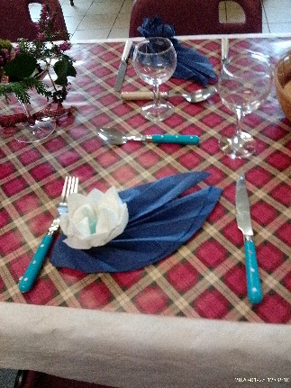

We had a planned Burns lunch, supper being too late in the evening for our, mostly, elderly congregations, but followed tradition with the Address to the Haggis, and the Selkirk grace.

Then began the Covid19 outbreak, and like everyone else, we had to find new ways of being church. Council began meeting via Skype, and reluctantly decided that we could not physically comply with the cleaning requirements of the two churches we use, not to mention that neither church has its own toilet facilities, and the municipal ones were locked! As mentioned earlier, we are an elderly group. We developed a phone around system, passing on information and sharing news. The biggest difficulty we faced, and are still facing, is communication. Very few of us live in towns, and remote country areas are not well served by the internet, loss of signal happens frequently, high winds, storms, and heavy rain quickly intervene. A few folk do not have internet, or the equipment to use it. We had real concerns about causing further isolation of them. Eventually we began to use Zoom, and our delayed AGM was our first outing on that medium. Encouraged, we had our first service, and have found that, as time has gone on, more and more people have joined in. We were able to run a Lent Group. And so we continue to follow guidelines, and even in this most recent lockdown are able to “meet”. If not physically, but in fellowship through our love for the Lord.

