Report from St Albans Chaplaincy, Strasbourg, 2020
Yes it was a year rather unlike any other - but in many ways we were very fortunate. Firstly we were very fortunate because we only had to suspend church services or rather pass to weekly ZOOMs for some three or so months.
The church of the Dominicans where we meet on Sunday mornings is largish and well ventilated. After church services were once again allowed from 7th June, Trinity Sunday, the church was carefully arranged to allow social distancing and there was space for seventy worshippers. Since then we have been able to celebrate Christmas and Easter together as a masked community.
We were also able to celebrate the 70th anniversary of the restoration of Anglican worship in Strasbourg in 1950. On the initiative of a small group of Anglicans who were early staff members of the Council of Europe, founded in 1949, arrangements were made for an Anglican priest to visit Strasbourg to hold monthly services and it has grown from there.
When we began to meet again in person we discovered over the months that the number of people coming to church was equal to those attending before the pandemic arrived, and that we were fortunate in that our income was not seriously affected.
Continuing the work with the children has not been easy but it has been possible to keep the regular Bible class which meets every fortnight for children aged from seven to twelve.
Help to close the gap in our outward charitable giving came from one member of our the community - a brave ninety year old - who, inspired by Captain Tom Moore, decided to do a sponsored walk. In two months he walked ninety times around his house and garden. His efforts raised enough money to allow us to meet our commitments to the organisations we support. They more than ever needed support in these difficult times.
We took to heart the call from the Diocese to respond to the Church of England’s call to become a zero carbon emissions church by 2030, and have set up an environmental group to oversee and advise our community on contributions that we can make towards this ambitious goal.
Yes, we miss the easy contact of meeting after coffee, but people have kept in touch by email and telephone. Our priest has remained positive – although that must have been hard. We are sure that this time can be a chance to look hard at ourselves to see what we will take into the future and what we would we will decide to leave behind.

A distanced congregation

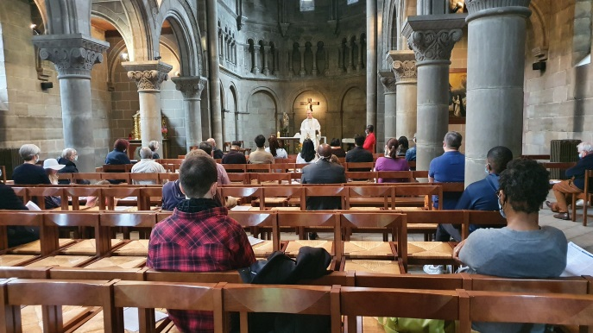

Diane Murray Sarah Palmer

