St Michael’s Anglican Church
Beaulieu sur Mer

St Michael’s Church was granted ‘Monument Historique’ status in 2020

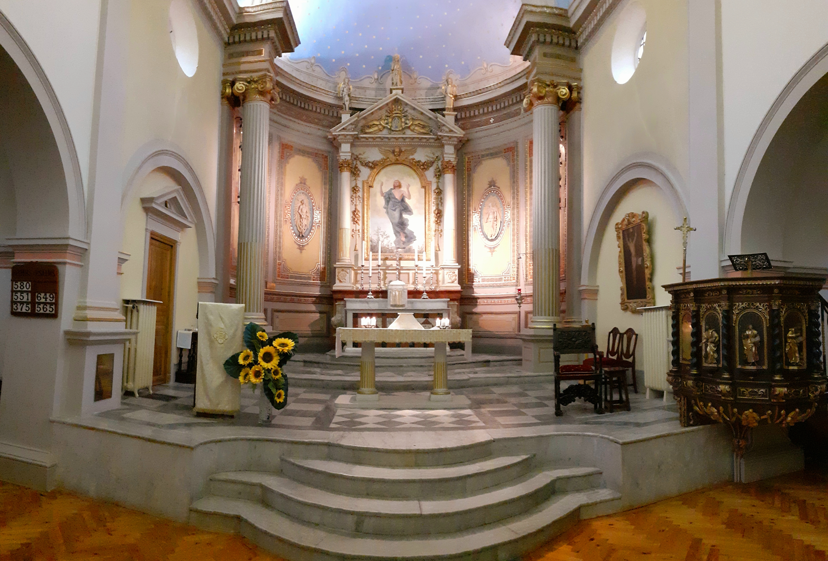

Chaplain’s Report (…part of the Annual Report for the Annual Church Meeting 2021)

This report covers the period 1st January to 31st December 2020.

The Church and Chaplaincy

St Michael’s was no different to many other churches within the Diocese and throughout the world. The measures to contain the Coronavirus pandemic meant changes to the way we conducted the Liturgy; attendance was restricted and the congregation had to sanitise, wear masks and maintain social distancing. Adhering to the regulations and guidelines of the French Authorities and the Diocese, we had to suspend singing, the physical Sign of Peace and communion from the chalice. The church had to be closed for a total of 96 days during lockdowns, however, we were determined to keep the church open either for private prayer or public worship whenever we were permitted. The disruption to international travel and the impact of quarantines in various countries meant that our usual congregation could not come to Beaulieu and so the statistics for 2020 were bound to be much lower compared to 2019.

We managed to celebrate a total of 66 services - 43 eucharists, 2 baptisms, 1 funeral service and 20 other prayer services. This was down by 55 compared to the previous year. Total attendance at St Michael’s for the year was 1,592 (down by 1,907) with an average Sunday attendance of 29 and a total of 997 communicants (down by 914). In addition, the chaplain was also able to celebrate a further 23 eucharists, 1 baptism, 3 funerals and 1 prayer service in support of St Paul’s Church, Monaco while their chaplain was indisposed.

As a result of the Covid-19 measures, St Michael’s had to cancel a number of social events - the Passover meal and our usual lunches at Pentecost and St Michael’s Day. We also suspended refreshments after services. All wedding blessings were cancelled, as were the usual services for the Danish Lutheran Church, the Assemblee de Dieu and the planned Sung Evensong. The annual Advent Service was scaled down considerably but nevertheless took place.

Following the murder of churchgoers in a terrorist attack at Nice Cathedral, the threat level in Beaulieu was heightened and for several Sundays local police and Gendarmes provided a reassuring guard at the church during services.

Despite the reduction of services and attendances there was still plenty to be done. New service sheets for Said Eucharists, Advent and Christmas were produced to reflect the changes to our Liturgy. During the year 56 sermons were preached at St Michael’s; 31 Home Services were produced and published; Zoom Services for Easter and Ascension were organised with each attended by over 50 people from around the world. A decision was made not to engage in live-streaming or videoing actual services because our resources would not do justice to the Liturgy. We also wanted to take the opportunity to promote the experience of personal spirituality and a sense of looking forward to physically attending public worship again.

During 2020 we managed to complete the second phase of our restoration project and there now remains only the sanctuary marble to be repaired. This investment into the church building was all the more important as it was confirmed by the French Ministry of Culture that St Michael’s was now an Historic Monument –warranting a news item on French television and articles in the press!

Chaplaincy Church Council (Association)

Our CCC members continued to be active supporters during the year. Zoom and WhatsApp enabled meetings and discussions to take place when we were not permitted to gather and the Annual Church Meeting, postponed from Palm Sunday, was eventually held in the church in September. Many thanks to the Secretary who ensured reports were prepared and submitted in advance so they could be e-mailed to members. Following the ACM the registration as an Association Cultuelle was updated with the Prefecture.

Many thanks also to the Churchwardens and other members of the Council who remained active, often behind the scenes, to ensure that we could meet the challenges the year brought. Consequently, the church building, and garden were always ready for when people returned.

Community

We were sad to announce the deaths of members of St Michael’s or their relatives during 2020 – Elisabeth d’Andrimont, Linda Colins, Ewa Grant, Susanna Noel, Rex Thorne, Liesbeth Tinker and Lily Weber. They are still sorely missed by their loved ones and friends and will be remembered by name in prayers on their anniversaries.

During the pandemic we were limited in what we could do pastorally. The safety of those who were already vulnerable curtailed visiting other than by their carers or nurses. However, we managed to provide some ‘meals on wheels’, virtual apéros and contact via phone and Zoom. Fiona’s initiative to send the Peace each Sunday on WhatsApp was particularly appreciated.

We also maintained contact with our world-wide congregation through a series of 21 short videos that focused on Beaulieu, the Liturgy at St Michael’s and Keeping in Touch. Fiona did a great job filming them , Eric did a magnificent job at editing each one and Hugh made sure they were accessible via the Messenger and our web site. With regard to the Messenger, we were able to submit over 20 articles plus various supplements to maintain our monthly contact with our people and apprise them of the changing situations at the church.

During the pandemic much of Beaulieu’s normal social activity was either cancelled or limited. We did however manage to take part in the few civic commemorations that went ahead, with delegates from St Michael’s joining the Mayor and dignitaries to lay wreaths at the Monument aux Morts for Victory Day, Bastille Day and Armistice Day.

Financial Impact

The consequences of the pandemic inevitably led to concern over the church’s financial situation. We have calculated a total loss of almost 14,000 euros for the year as a result of church closures, smaller attendance and the cancellation of special services and events which otherwise would have normally contributed to our annual income. However, the special appeal to help off-set this loss raised just over 5,500 euros and so a very appreciative thank you to all those who gave their additional support to the church. I am pleased to say that at the end of the year (subject to the final Treasurers’ Statement and Examiner’s Report) both Total Income and Basic Income exceeded Total Expenditure and Essential Costs once again. However, the long-term effects of the pandemic are quite likely to reach well into 2021 and so we continue to carefully monitor our finances.

Summary

We have often referred to St Michael’s as being a haven of peace. That, however, carries the risk of us becoming insular and inured to the problems and crises that beset other people and the world beyond Beaulieu. The pandemic in 2020 brought such problems and crises into our own lives as we have shared in knowing relatives or friends who have succumbed to illness, death and bereavement; we have shared to some extent in the anxiety as we have tried to keep ourselves and one another safe from infection; everyone’s routines have been disrupted with lockdowns, quarantines and curfews. This has been a year of realising our own frailty and for us to have an even greater empathy for all who are in a much worse place. St Michael’s must not just be a haven of peace but a powerhouse of prayer. Our heartfelt prayers for brothers and sisters in great distress and hardship around the world are the result of the Holy Spirit working within us and it is from the Holy Spirit that we derive the faith to keep us in hope, peace and love for one another.

‘May the God of hope fill you with all joy and peace as you trust in him,
so that you may overflow with hope by the power of the Holy Spirit.’ (Romans 15:13)

Fr A W Ingham 22 January 2021
Priest-in-Charge

