Webinar held on Thursday 19 February
What you need to know in order to decide whether to move to Theo-Asso
The webinar was led by Stéphane Hamelin, CEO of Theoasso. Alain Ledain (developer of Caleb), Uto Tuikalepa (technical director or Theo-Asso) and Benjamin Callebaut (externalised accounting advisor of Theo-Asso, also partner in an accounting firm) also took part.
This webinar is to add to the information provided in the first Webinar on 22 January in order to allow Caleb Gestion users to decide whether or not to move to Theo-Asso.
This will primarily by trying to answer questions that came out of the 22 January Webinar.
- Why did Alain Ledain sell his application given it is working well?
VB6 technology is old and may not continue to work with future versions of Windows. It also does not allow the development of certain functions and in particular it cannot work online.
There are 3,000 users, but only Alain Ledain on the Caleb side so this dependence is not viable, even if the Actes6 team provide support in relation to documentation and training.
- If I don’t choose Theo-Asso, can I still use Caleb Gestion?
Users have purchased the software – it is theirs. They are free to decide to continue to use it – it will not suddenly stop working. However, as the technology is old and as mentioned above, it may not be compatible with future versions of Windows. Also, it will not be updated for example for changes to accounting requirements, and so in time will not meet all necessary accounting requirements.
- With Caleb Gestion users still get technical support?
Alain Ledain will not abandon his clients. Technical support will continue for 2 years (to the end of 2027), while the migrations are taking place. After 2 years, Alain will not suddenly stop giving support, but he will be making a strong recommendation to Caleb users who contact him that they migrate to Theo-Asso?. Also, from 2028 Theo-Asso customers will be given priority over Caleb users so the response times will be greater for Caleb.
- Will Caleb Paie continue?
Caleb Paie is separate from Caleb Gestion and has not been sold to Theo-Asso. However, it uses the same technology as Caleb Gestion so the same risks in relation to future compatibility with new versions of Windows also apply. Alain will continue to update Caleb Paie so it can continue to be used.
- What happens about contracts I have with Actes6?
- A new offer is in the process of being developed to replace the current Optimum pack in order to integrate Theo-Asso as well as Caleb Gestion. There will be a communication when this has been sorted out as to what the future offer will be. It will however be similar to the Optimum offer in most aspects.
- Is Alain Ledain still happy about his decision to hand over to Theo-Asso?
Yes he is. He is satisfied that the temperament of those taking over, and particularly Stéphane, is consistent with the way he operated Caleb Gestion.
- What is the latest version of Caleb Gestion?
The latest version is Caleb 24. This was issued in 2025 and there is no correlation between the version number and the year. There will never be a version 25 – although there may be updates to 24 if needed until Theo-Asso is in place.
- What is a Pack Serenité?
It is an offer in relation to the transition. The main objective is to make sure that the migration goes smoothly. Although certain aspects, such as the pure accounting entries, will be relatively easy to migrate, there are other data sets – in particular those relating to donations management – which are much more complex. Theo-Asso therefore wanted to provide an all-inclusive service to Caleb Gestion users so that they need not have any concerns about the migration process.
That said, taking the Pack Serenity is not compulsory and those that think they are able can migrate from Caleb Gestion to Theo-Asso themselves. But at their own risks and perils and may result in only part of the data being transferred.
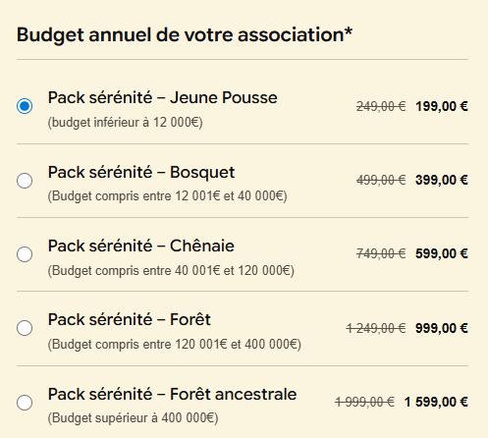
There is a 20% discount if the Pack is purchased before 31 March 2026.
The pack can be purchased on the theo-asso website (https://theoasso.com/) and the pricing depends on the size of the association (based on budgeted income). Payment can be by bank transfer, credit card or direct debit using “GoCardless”.

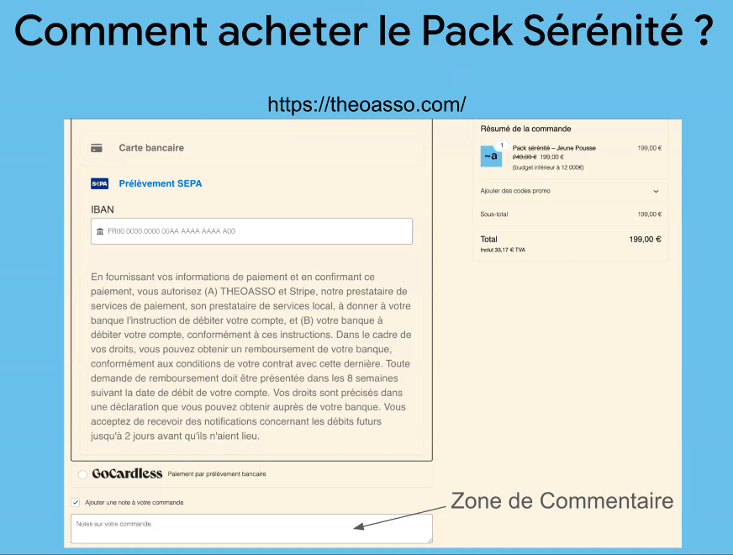
When on the payment page, Stéphane asks that the comments box be used to give the name of the Association Loi 1905 to link with other information relating to the migration process.
On payment, an email will be sent out with an invoice and a link to the Caleb Gestion upgrade page if your association is not already using version 24.
It includes an upgrade to the latest version of Caleb Gestion (for those not yet using Caleb 24), full support for the migration to Theo-Asso, the new mobile phone application Theo-bills (credit card payments, expense claims, mileage claims) and membership of the Theo-Asso community.
It is a one-off charge and means that once paid there will be no other payment to Theo-Asso until the actual new software is released in the first half of 2027 (after which date the monthly charge will become payable).
Anyone who decides to move to Caleb Gestion during 2026 (so new users) will also be entitled to benefit from the Pack Serenity.
Some think this is expensive. However, this is primarily in comparison to the very low cost of Caleb. Comments received from Caleb users who are involved with IT in their professional lives have confirmed that, compared to what they see in the commercial world, the Theo-Asso migration charge is very reasonable.
- What happens if Theo-Asso does not sell enough Pack Serenity to finance the development of the new software?
When Alain selected Theo-Asso as the buyer of Caleb, he insisted that the financing of development was assured independently of any revenues from selling the transition package. Sales of Pack Serenity will, however, significantly help with cash flow and allow development teams to be hired faster than if there is no such revenue. This will mean that a higher level of Pack Serenity sales will mean that additional features are available earlier in Theo-Asso but will not impact the timing of release of the new software in the first half of 2027.

- How much with the new software cost?
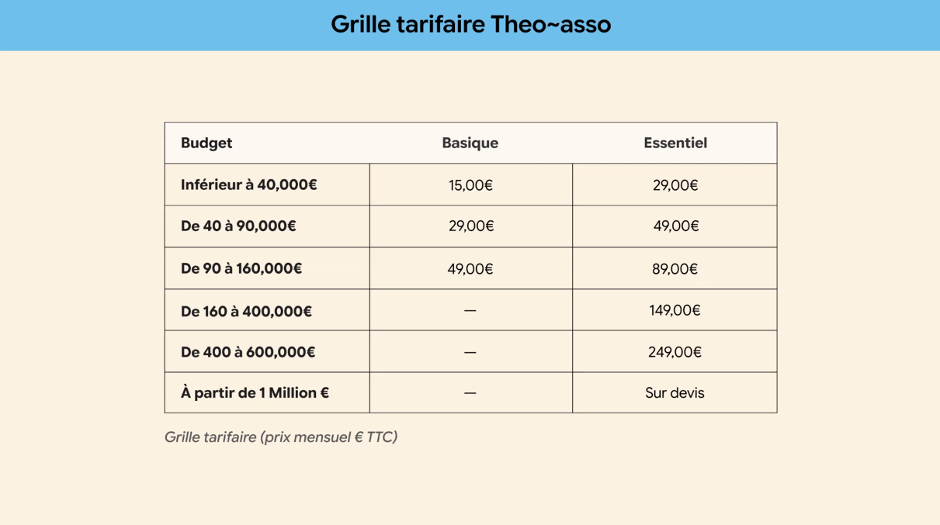
The basis for the monthly charge is, therefore, the income levels of each user. There are also two versions:
- Basique – which corresponds to the functionalities of Caleb Gestion as it is now, including the donations module of course. This version will only be available for associations up to €160k in income on the basis that above that level many users will require a statutory audit and so the new features will become necessary to allow them to satisfy the requests of the CaC.
- Essentiel – will includes the new features that the new technology will allow, as they are developed. Will include for example automatic upload of bank information, Theo-Bills, the notes to the accounts (not available in Caleb Gestion or the Basique version).
This charge includes the Loi 1905 association plus one additional Loi 1901 association given almost all Churches are required to separate their ecclesiastical and social activities. There will be a limit to the size of the 1901 association for it to be included free, although this limit has not been set yet. It will be announced in the Autumn. Stéphane did however mention income of €25k to €30k as an example.
At the 22 January meeting, Stéphane had announced a 10% discount for life for those who purchased the Pack Serenity. In fact, this has now been dropped as it was neither economically viable nor possible to manage.

- How will the migration work?
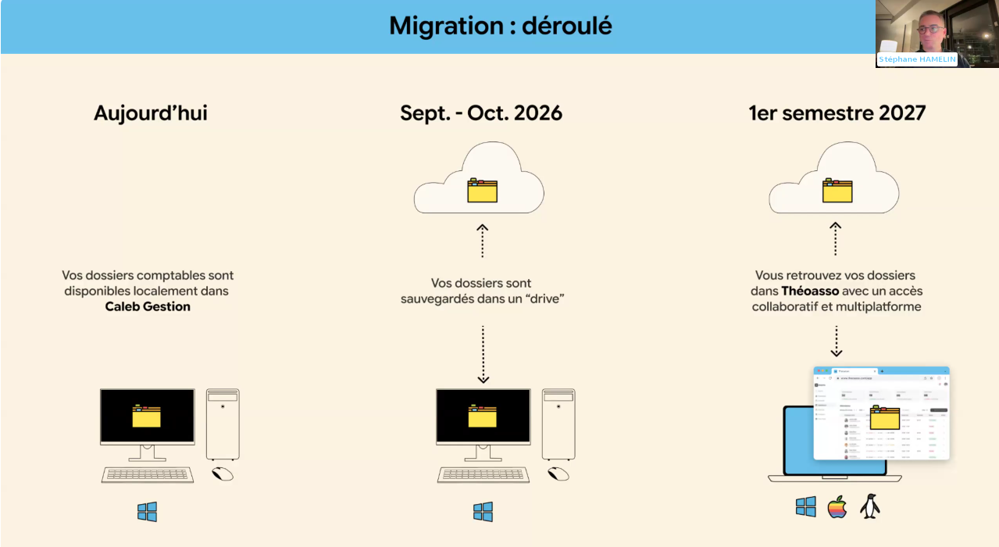
In September, a drive will be made available where Caleb Gestion back-ups can be stored. This will allow the migration team to check if there are any specific issues likely to arise. It will also mean the data is already available when the actual migration takes place in Spring 2027.
Based on the data on the drive, the migration team will let you know when they consider your data is ready to migrate and then you will be able to choose the precise timing of that migration. The drive will include a “widget” that keeps you informed of the status of data preparation.
When everything is ready, there will be a button to click to activate the use of Theo-Asso – and it should be as simple as that as all the leg-work will be done by the Theo-Asso team.
The information migrated will be as follows:
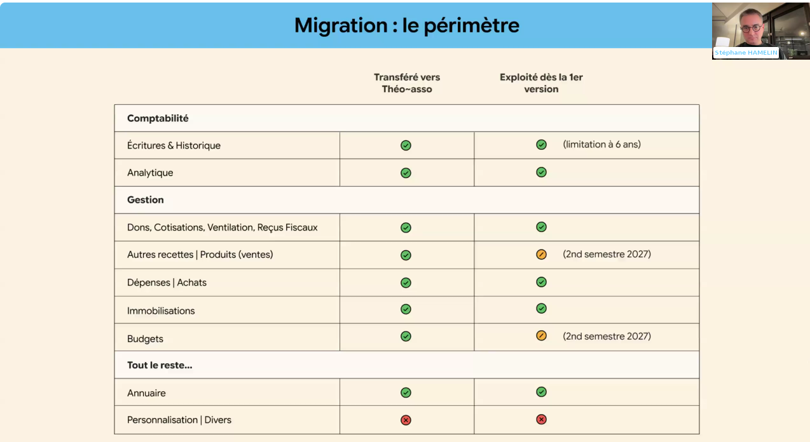
For other sales activity and budgets, the data will be transferred but it is not expected that the new module will be available until later in 2027 – unless a huge number of Pack Serenity are sold to give the resources necessary to develop faster!
The last line “personalisation/divers” refers to the formatting of invoices, signatures, etc. in Caleb Gestion. Equivalent features will be available in Theo-Asso but they will need to be recreated as they cannot be migrated as not exactly like-for-like.

- What is the risk that the new development will not work?
Stéphane and Uto acknowledge that there is not a zero risk. However, the team has been set up with experience of transformation projects in large entities and so have already been there and done that in environments that are much more complex that the transfer of Caleb Gestion to Theo-Asso. So they are confident that they will be able to deliver on time.

- What are the technical characteristics of the new software?
These will take into account the requirements of accounting standards, data privacy (RGDP), cyber-security,…
The new tool is not going to reinvent what is already working correctly in Caleb, but “just” transfer it into new technology which does make the project more straight-forward.
The data centre chosen in based in Switzerland – and is not linked to the GAFA.

- What about invoicing in Theo-Asso and electronic invoicing?
Commercial companies are required to use electronic invoicing from September 2026. But this does not apply to not-for-profit associations with no commercial activity, so you don’t need to think about it. Unless you do sell goods (books, souvenirs,…) above a certain limit (not defined on the webinar but seeming the commercial activity is greater than the ecclesiastical activity), but even then you do not need to use electronic invoices but instead declare your activity by eReporting to the tax authorities. If you do have a commercial activity and/or are registered for VAT then electronic invoicing is necessary.
Caleb’s invoicing tool is not compliant with electronic invoicing, nor registered as a registered platform. So Caleb cannot issue or receive electronic invoices.
If your association is VAT registered then it will be necessary to register with an appropriate invoicing platform – Stéphane can give some references if required.

- If I have Theo-Asso do I need an Expert-Comptable and if I have an Expert-Comptable do I need Theo-Asso?
The two are not directly linked. If you hire an Expert-Comptable it could be full-service and so the EC uses their accounting software to keep the books. However, it is very unlikely they will be able to manage donations with their tool so either you will have to do it manually or the EC will have to do it manually. It is perfectly possible for you to complete the basic data entry with Theo-Asso and engage an EC to prepare year end (or perhaps quarterly) accounts and complete the non-recurring actions such as depreciation of fixed assets or closing the prior year accounts. So having an EC does not necessarily mean you do not need Theo-Asso as it depends on the scope of the ECs work.
On the other side, if you are using Theo-Asso do you need an EC. That very much depends on the competencies within your association as if the Treasurer has a sound financial background, they may well be able to do everything necessary. Alternatively, they may have picked up how to do the data entry, but are not knowledgeable about the wider financial situation – in which case you may hire an EC to assist with those non-routine matters.
Benjamin indicated that he is Treasurer of an association himself and he uses Caleb Gestion and not the accounting software of his accounting firm as the donation module is the key feature of Caleb.

